EDUPlan  
1/28/2025  
Version 0.1  
Justin Evans, Pradhyumna Kothapalli, Raven Griffin

1. **Project Description**
2. **Project Overview**

Web application that will help students select and prepare for their courses effectively. Using AI-based recommendations, EduPlan will provide students with course suggestions, insights into career pathways, study resources, and academic planning tools.

1. **The Purpose of the Project**

**2a. The User Business/Background of the Project Effort**

The web app will be a scheduling and study planning helper for students. The catalyst for this idea came from our own personal experience selecting courses early on in our college career, as it was not easy to find courses and studying materials that fit what we wanted. This web app will allow students to use an AI assistant to make course selection and preparation easier and more tailored for them, as well as help students with difficult topics once they are in a course.

**2b. Goals of the Project**

We want students to have an easier time selecting and preparing for courses.

1. **The Scope of the Work**

**3a. The Current Situation**

Currently, students rely on course catalogs, limited academic advising, and personal research to make course decisions. Due to the lack of personalized advice, students may be uncertain about whether a course aligns with their interests, skills, and career goals. Academic advisors provide guidance, but due to high student-to-advisor ratios and time constraints, many students just get general recommendations rather than advice specifically tailored towards them.

Additionally, students often enter courses without any preparation and struggle to find relevant study materials, external resources, and other tools to help them succeed. Without a centralized system to recommend study aids, students need to manually search for books, videos, or online courses, which can be both time-consuming and overwhelming.

**3b. The Context of the Work**

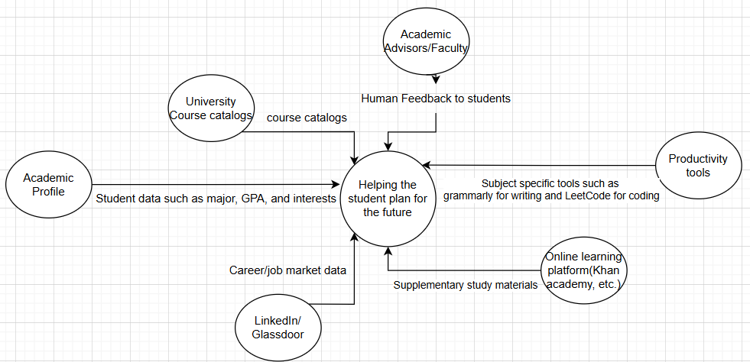

**3c. Competing Products**

Several existing options help students choose courses and plan their education, but they all have drawbacks. Manual course catalogs list available classes, but they don’t offer personalized recommendations, career guidance, or study resources, leaving students to figure things out on their own. Academic advisors give one-on-one support, but they are often too busy to provide in-depth, personalized advice, so many students receive general recommendations instead of tailored ones. Online learning platforms like Coursera and edX suggest courses for developing skills, but they don’t connect with a student's official school curriculum, making them less useful for structured academic planning. LinkedIn Learning helps students gain career-related skills but doesn’t integrate with high school or college course requirements, and it doesn’t help students choose the right classes for their education.

EDUPlan brings all these resources together into one easy-to-use platform, making course selection and academic planning simple and efficient. Instead of searching through different websites, course catalogs, and advisors for guidance, students can find personalized course recommendations, career insights, and study resources all in one place. By using AI, EDUPlan tailors suggestions to each student's academic background and goals, helping them make informed decisions quickly. This saves students time, reduces confusion, and ensures they choose courses that align with their interests and future careers.

Beyond just the course selection stage, EDUPlan remains a valuable tool throughout the semester. If a student struggles with certain topics, the platform provides recommended books, videos, and online learning materials to help them better understand difficult concepts and help students to stay on top of their coursework.

1. **Stakeholders**

**UNCG Students, UNCG**

1. **Requirements**

1. **Product Use Cases**

**1a. Use Case Diagram**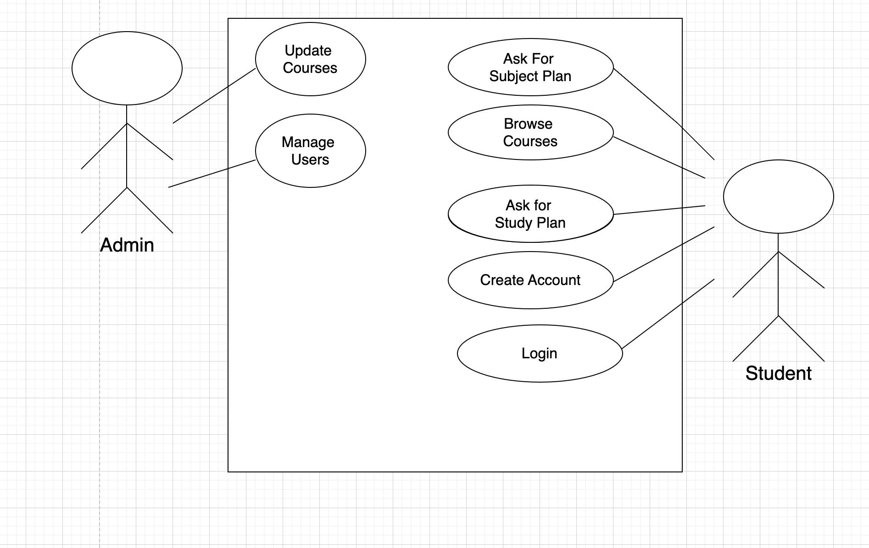

1. **Functional Requirements**

| # | Functional Requirement | Category | Notes | Priority |
| --- | --- | --- | --- | --- |
| 1 | System should allow users to easily find courses at their college that work for them | content display |  | High |
| 2 | System should give users a study plans to help them learn what they need when they need to know it | data |  | High |
| 3 | System should allow users to securely create and log in to accounts, as well as change their password if needed | data |  | High |
| 4 | System should allow signed-in users to modify their likes and dislikes for course selection and study plans | data |  | High |
| 5 | System should display course sections alongside the course catalog to help students better prepare for their semesters ahead | search |  | Low |
| 6 | System should allow users to ask questions about a course topic and receive further explanation on the topic | data |  | High |
| 7 | System should allow users to ask the for helpful resources on topics in the courses they are taking | data |  | High |